How much flexibility is available for a just energy transition in Europe? - A sensitivity analysis of CO reduction targets

Tim T. Pedersen[[1]](#footnote-2), Mikael Skou Andersen, Gorm B. Andresen

## Abstract

The transition of Europe’s energy supply towards carbon neutrality should be efficient, fair, and fast. The efficiency of the transition is ensured by the European Emissions Trading System (ETS), where emissions allowances are traded in a common market . Fairness is aimed for with the Effort Sharing Regulation, according to which there are specific national reduction targets for the non-ETS sectors (transport, buildings and farming) calibrated according to the economic capacity of Member States. These two pieces of legislation are the backbone of Europe’s energy supply transition, aiming for a trade-off between efficiency and fairness. In our research presented here, 30.000 Monte Carlo simulations of national reduction target configurations have been performed by means of an advanced energy system optimization model of electricity supply as of 2030. Results reveal a group of countries where emissions reductions beyond the national targets in most scenarios are economically favorable. On the other hand, for some countries large abatement costs are unavoidable. An efficient transition may be achieved by spatially allocating emissions to countries where abatement costs are high, while eliminating emissions in countries with low costs, e.g. due to generous renewable resources.

# Main text

## Introduction

The European Green Deal raises the ambition level for decarbonization of the European energy sector, in combination with explicit aims to ensure a just transition . The quality of a just transition is, however, not easily measured and has in recent years become a topic of much debate . Emissions from the energy sector are currently governed by the EU Emission Trading System (EU ETS) , operating on the cap-and-trade principle, requiring that all power generators in Europe buy emission allowances. The Just Transition Mechanism combined with the Just Transition Fund is introduced to ensure a more equitable transition . Since 2013, a fixed amount of emissions allowances has been auctioned off to power plants on an annual basis, hence setting a price on CO emissions and providing an incentive to limit these . By gradually lowering the amount of allowances on auction year by year, the EU ETS determines the overall rate of emissions reductions by EU Member States as a whole. The annual reduction rate will be fixed in accordance with the recently agreed commitment by the EU to reduce greenhouse gas emissions by 55% by 2030 . The burden of reducing emissions is moreover allocated among EU member states by setting national reduction targets. Emissions from sectors not covered by the EU ETS are determined through the Effort Sharing Regulation , translating the overall 55% reduction target into national targets for each Member State. The national targets are based on Member States’ relative wealth, measured by gross domestic product (GDP) per capita, to ensure a just transition . Still, some countries have unilateral reduction targets for emissions not governed by the EU ETS, such as the Swedish carbon tax. These targets may distort the market price of CO allowances in the EU ETS and lead to carbon leakage which may decrease overall welfare .

The European power sector is on the verge of a major transformation from a fossil-fuel based system to rely mainly on renewable and low-carbon resources . However, the starting point differs widely, with some countries having already high shares of carbon-neutral energy sources, while other countries still are deeply reliant on fossil fuels . The transformation of domestic energy supply is challenged by several factors of technical, economic and political nature. The access to renewable resources , currently operating power plants, and availability of international transmissions connections are some of the key technical parameters. Figure [[fig:starting\_point]](#fig:starting_point) a) shows the capacity of plants installed today and expected to remain in operation by 2030. It is clear, that the premises for rapid decarbonization are very diverse, with some countries relying heavily on coal and oil, while others have a large pool of renewable power generators. Figure [[fig:starting\_point]](#fig:starting_point) b) shows the potentials for renewables per Member State. Renewable potentials are calculated as geographical potential for renewable capacity multiplied with the average national capacity factor for the given renewable resource (reference for geographical potentials). It is evident that the renewable potentials are unrelated to country size and energy demand. The vastly different starting points of member states should be captured by the EU ETS and the Effort Sharing Regulation if a just transition is to be achieved.

image

A uniform CO price is said to be the most efficient way to achieve emissions reductions . However, with the uniform CO price, the justice of the transformation cannot be ensured. Allocating the global carbon budget to ensure fairness is however a daunting task with many possible outcomes. Zhou and Wang identify a range of allocation schemes, based on different principles, such as sovereignty, egalitarianism, efficiency, horizontal equity, vertical equity and polluter pays. Other studies combine these philosophies to create more complex allocation schemes, such as the Model of Climate Justice per capita , where historical emissions along with population growth are considered. Choosing a single right allocation scheme is inherently difficult as it is not a question about costs but rather one of ethics . Markowitz notes that we are ill-equipped to decide, given the complexity of the problem, and our own complicity in causing it . Still, Jenkins et. al. identify three core tenets of energy justice: Distributional, recognition, and procedural . Distributional justice recognizes the unequal distribution of environmental benefits and provides the rationale for this research. Recognition justice states that individuals must be fairly represented and have equal rights, whereas concerns access to the decision-making process. Only distributional justice will be considered in this work.

Schwenk-Nebbe et. al., consider three different allocation principles for establishing national CO reduction targets in a European context that are of interest here. In their paper, emissions are allocated based on cost efficiency, sovereignty (local-load) and grandfathering (local-1990). The efficiency scenario applies a uniform CO price, the sovereignty scenario allocates emissions proportional to national electricity demand, and the grandfathering scenario allocates on the principle of historical emissions. In their analysis, Schwenk-Nebbe et. al. find that with the Efficiency solution, remaining emissions will be concentrated in a small number of countries where the costs of decarbonization are highest. Allocating emissions after the Sovereignty or Grandfathering principle respectively will distribute remaining emissions more evenly while implying a spread in unit abatement costs and higher total system cost. Bauer et. al. studied the trade-off to be made between economic efficiency and sovereignty in a global context using a multi-objective approach. Their findings indicate a highly non-linear trade-off between efficiency and sovereignty, where the intermediate scenarios can secure higher total benefits. The studies by Schwenk-Nebbe and Bauer do, however, only analyze a fraction of the possible ways national CO reduction targets can be distributed. As found in , there are numerous allocation approaches resulting in a vast number of emission allocations.

In this research, a Markov Chain Monte Carlo (MCMC) method has been employed in combination with a techno-economic optimization model of the European power supply system to identify and study all the possible configurations of national reduction targets. The reduction allocation configurations are represented each with a unique set of national reduction targets for all of the modeled countries. Two criteria are required of the reduction target configurations. First, a combined CO reduction of at least 55% must be achieved by the model countries according to the EU’s 2030 Climate Target Plan . Second, the total system cost of implementing the reduction targets must not increase by more than 18% relative to the cost-optimal allocation of targets. This constraint is based on the principles from Modeling to Generate Alternatives (MGA) where economically near-optimal model solutions are studied . Applying MGA methods to energy system optimization models has gained a lot of attention . MGA has, however, mainly been used to study technical flexibility among the near-optimal solutions . The method employed in this work consists of two steps. First, using a MCMC method to devise a random set of national CO reduction targets for the model countries. Second, the total system costs of the reduction configurations are then evaluated using an energy system optimization model. If the reduction target configuration satisfies the two afore-mentioned criteria, it is accepted and stored. If not, the outcome is rejected. This process is iterated until a sufficient sample size is obtained. The result is a huge set of configurations of national reduction targets comprising all potential configurations satisfying both criteria.

The novelty of this work lies in the combination of a power system optimization model and MCMC methods to study the possible configurations of national reduction targets in a European context. Where previous studies have used scenario-based modeling or multi-objective optimization to study a small range of possible solutions, the method applied in this work is capable of identifying a much larger range of possible outcomes. Furthermore, detailed information about each configuration of national reduction targets can be obtained, as the power system optimization model solves for each allocation scheme.

## Method

The aim of this paper is to analyze the implications of different potential allocations of the national reduction targets and their effects on the European power system. The criteria listed in Table [[tab:feasa]](#tab:feasa) indicate which configurations that can be considered feasible. In addition to these criteria, it is required that the energy system optimization model remains solvable under the reduction target configuration, while national level emissions of each Member State must not surpass the equivalent of supplying 150% of demand with coal power. These additional criteria prevent very unrealistic scenarios from being included.

|  |  |
| --- | --- |
| a) | The joint CO reductions must be equal to or greater than 55%. |
| b) | Total system cost of the configuration of national reductions should not exceed the cost optimal scenario with 18%. |
| c) | A technically feasible solution to the model exists. |
| d) | National emissions must remain below the equivalent of supplying 150% of energy demand with coal. |

To identify the possible reduction target configurations a modified version of the Adaptive Metropolis-Hastings (AMH) sampler is used . The sampler falls under the broad umbrella of MCMC samplers. By using the AMH sampler to efficiently sample possible configurations of national reduction targets, while rejecting configurations considered infeasible, it is possible to approximate the overall distribution of the feasible reduction configurations. The sampled variables are the national CO reduction targets for the model countries. Using the AMH sampler, distributions approximating the distributions of all feasible configurations of national reduction targets are obtained. A detailed description of the sampler is available in the appendix.

Next, the sampled configurations of national reduction targets are evaluated using an energy system optimization model of the European power sector. The model uses the PyPSA-Eur-Sec framework to define a model spanning 33 ENTSO-E (European Network of Transmission System Operators for Electricity) member countries. (thus the model includes EU-27 without Cyprus and Malta, along with Norway, Switzerland, Serbia, Bosnia-Herzegovina, Albania, Montenegro, Macedonia and United Kingdom). A 2030 brownfield scenario is modeled, where all installed generator capacities as of 2019 that are expected to be in operation in 2030 are included. To cover energy demands the model will install new generation capacity, where it is economically optimal. The model uses a one node pr. synchronous zone setup, with the nodes connected by high voltage AC and DC lines. Using one year of energy demand and weather data resolved in 3 hour time-steps, the model determines the cost-optimal dispatch, power flows, and investment in new generator capacity. Transmission line capacities included in the model are the currently installed capacities, plus the planned capacities from the Ten Year Network Development Plan (TYNDP) . The energy-generating technologies included are hydro, onshore wind, offshore wind, solar PV, CCGT, OCGT, coal, lignite, nuclear, and oil. Furthermore, two storage technologies are included. These are hydrogen and battery storage. The technology parameters are listed in Table [2](#tab:tech_data). Brownfield capacities are shown in Figure [[fig:starting\_point]](#fig:starting_point) and in Table [3](#tab:brownfield_cap). The national CO reduction targets provided by the AMH sampler are included as constraints in the model, limiting CO emissions from energy generation in each of the modeled countries. Still, modeled countries are free to overperform on the national CO reduction target if it is economically favorable.

Technology cost predictions for 2030 are used for all expandable generator types. Data for technology costs are indicated in Table [1](#tab:tech_cost). 2013 is chosen as the meteorological reference year, as the hourly demand and weather profile is a good representation of an average year. A single model evaluation can be completed in approximately 15 minutes on a 4 core machine with sufficient memory. Solving the optimization problem 30.000 times, requiring 15 minutes each, was performed using 10 parallel threads, resulting in roughly 30 days of computation.

By evaluating the results of the energy system optimization model for a given configuration of national reduction targets, it is possible to determine whether the configuration satisfies all criteria of Table [[tab:feasa]](#tab:feasa). Each configuration can then be accepted or rejected based on the result.

| Name | Interpretation | Rule |
| --- | --- | --- |
| Grandfathering | All nations have equal right to pollute | Distribute emissions proportionally to historical emissions |
| Sovereignty | All nations have equal right to pollute | Distribute emissions proportionally to energy demand |
| Efficiency | Maximize global welfare | Distribute emissions to reduce total socio-economic costs |
| Egalitarianism | All citizens have equal right to pollute | Distribute emissions proportionally to population size |
| Ability to pay | Nations with higher welfare should take on a larger part of the task | Distribute emissions inversely to GDP per capita |

### Method limitations

Weather and demand patterns are expected to change as a result of global warming and general electrification of energy use. Investigating these effects is, however, beyond the scope of this paper. Only the electricity sector has been modeled. The effects of sector coupling are only expected to be moderate by 2030, thus this simplification is believed to provide only a minor source of error. If sector coupling was implemented, the electricity sector could be expected to achieve a higher decarbonization rate than involved with the 55% target, as it is considered easier to achieve here than in other sectors. Emissions of Nordic countries (Norway, Sweden, Finland) that have achieved a high decarbonization in the electricity sector would however rise, as they are still relying on oil and gas for industry and transportation.

## Results

Five principles for allocation of national reduction targets are of interest here. Based on section [[sec:method]](#sec:method), these are grandfathering, sovereignty, efficiency, egalitarianism, and ability to pay. The procedures for the allocation of national reduction targets, and conversely the emissions, for each of these five principles are shown in Table [[tab:scenarios]](#tab:scenarios). Using these five principles, six emission reduction configurations have been created as seen in Figure [[fig:co2\_scenarios]](#fig:co2_scenarios). The Efficiency 55% and Efficiency 70%, configurations correspond to using EU ETS at 55 and 70% joint reductions respectively, whereas, the Grandfathering, Sovereignty, Egalitarianism and, Ability to pay configurations represent alternatives to EU ETs. These configuration principles are implemented such that they all distribute the same CO budget, except for the efficiency 70% reduction configuration. As allowable emissions are left unused by some countries, as they find it economical favourable to do so, the global CO reduction for all configuration principles other than Efficiency, will be higher than the minimum goal of 55%. The configuration principles could alternatively be implemented to all have realised emissions corresponding to a 55% CO reduction. A choice was made to use configurations with equal CO budgets rather than equal realised emissions, as they represent a more diverse set of scenarios. For results using configurations with equal realised emissions see Appendix Section [[sec:all55scenarios]](#sec:all55scenarios).

Applying the described MCMC method, a total of 30.000 random configurations were drawn, with an acceptance rate of . All samples were saved allowing for analysis of emitted CO, technology investments, and electricity prices.

In Figure [1](#fig:co2red_cost), the resulting joint CO emissions from all configurations of national reduction target allocations is shown, plotted against their total system costs. The reference scenario (Efficiency) with the lowest total system cost is indicated with the red cross. The Pareto optimal front was calculated by continuously decreasing the allowed joint CO emissions and is indicated by the blue line.

Histogram showing the CO_2 reductions relative to 1990 and the associated costs of all feasible configurations of national reduction targets, relative to the cost-optimal solution. The minimum required CO_2 reduction and maximum allowable cost increase is marked with red lines. The blue line marks the Pareto-optimal front of a dual objective optimization procedure using total system cost and joint CO_2 reduction as the two objective functions. The reduction target scenarios Efficiency 55%, Efficiency 70 Grandfathering, Ability-to-pay, Egalitarianism, and Sovereignty are marked with orange.

Histogram showing the CO reductions relative to 1990 and the associated costs of all feasible configurations of national reduction targets, relative to the cost-optimal solution. The minimum required CO reduction and maximum allowable cost increase is marked with red lines. The blue line marks the Pareto-optimal front of a dual objective optimization procedure using total system cost and joint CO reduction as the two objective functions. The reduction target scenarios Efficiency 55%, Efficiency 70 Grandfathering, Ability-to-pay, Egalitarianism, and Sovereignty are marked with orange.

In the figure, a gap between the Pareto optimal front and the actual outcomes can be observed. There is nothing preventing the sampler from identifying configurations on the Pareto optimal front, it is, however, very unlikely. The probability of the sampler drawing the exact combination of the 33 variables that will lead to a Pareto optimal solution is very low. This also shows that the optimal solution is an extreme scenario that is very hard to obtain without extensive collaboration and agreement between all model countries. This is very unlikely, as countries have individual national targets and agendas. Therefore, we argue that solutions located in the dark blue regions of Figure [1](#fig:co2red_cost) can be considered as significantly more probable outcomes, because they can be realized with many different configurations of national reduction targets.

All the allocation principles, except Efficiency 55%, are seen to provide a higher CO reduction than required. This over-performance on emissions reduction is a result of several countries finding it cost-optimal to reduce emissions beyond their assigned national target. In the Efficiency configurations only a joint CO emission constraint is used which is binding for all countries. In all other scenarios national CO emission constraints apply. In scenarios with reductions becoming higher than 55%, the national CO constraint is not limiting in one or more countries. The Grandfathering and Ability to pay schemes are located close to the Pareto-optimal front, whereas the Sovereignty and Egalitarianism are found to deviate significantly from the Pareto-optimal front.

Considering the distribution of the joint CO reduction, it is clear that the probability of achieving reductions close to the joint target (marked by the red line) is more likely than overachieving. Moreover, the distribution of the system costs reveals that an increase in the total system costs of not less than 5% relative to the cost-optimal scenario is almost unavoidable, since, to obtain the lowest possible total system costs, the burden of transitioning must be shared in a very exact way. It is, nevertheless, very unlikely that this will happen as countries have different national ambitions. Therefore costs higher than what is deemed optimal is to be expected. What Figure [1](#fig:co2red_cost) further shows, is that this cost increase with a 75% probability will be above 4.6% and it has a 50% probability of being between 4.6% and 12.2%.

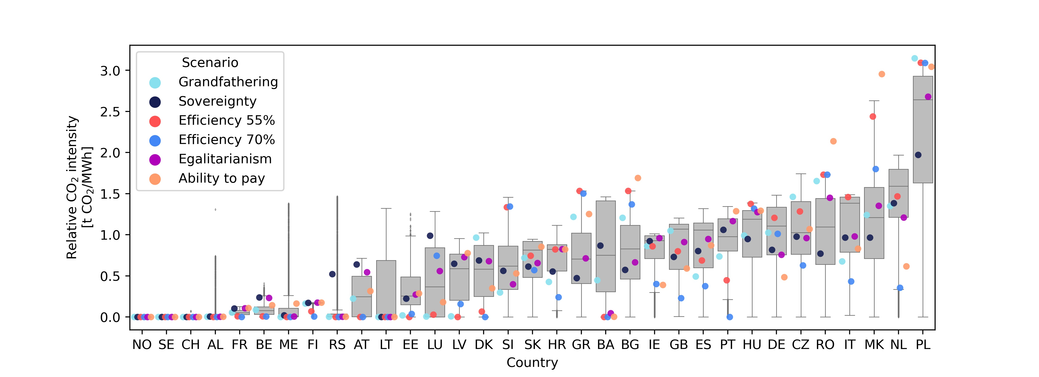

Figure [[fig:co2\_mwh\_box]](#fig:co2_mwh_box) shows the probability range for CO intensity (emissions per MWh) in each of the modeled countries according to the various configurations of national reduction targets. As seen in the figure, all countries have zero emissions in one or more configurations. Countries such as Norway and Sweden have zero emissions under all circumstances. This is not because they are allocated a demanding reduction target, but simply because it is cost-optimal to rely fully on renewable or nuclear energy. On the other hand, countries such as Poland and North Macedonia tend to have large emissions intensity in most configurations. By analyzing the configuration of national reduction targets in the Efficiency approaches, it can be observed that higher than average shares of emissions are allocated to countries that at the outset have high emissions and less than average shares of emissions are allocated to countries with low initial emissions. In other words, the Efficiency schemes favors assigning modest reduction targets to countries that have a hard time reducing emissions and cut emissions drastically in countries where CO reduction is easier. This intuitively reduces total system cost. When comparing the Efficiency scenario with 55% and 70% reductions, we can identify countries that are next in line to reduce emissions such as the Netherlands, Italy, and Great Britain, as they all reduce emissions substantially in the 70% scenario. There is, however, also countries where the emission intensity is undisturbed even though joint emissions have been reduced. In the Sovereignty scenario, CO reduction targets are assigned equally based on the national energy demand. Naturally, a much more even emissions intensity results from this approach. In the Ability to pay approach emissions are distributed inversely proportional to national GDP per capita. This redistribution of emissions with the Ability to pay approach is clearly discerned in Figure [[fig:co2\_mwh\_box]](#fig:co2_mwh_box), where wealthy countries such as Germany and the Netherlands end up with low emissions while countries such as Romania, Macedonia, and Bulgaria feature higher emissions.

By analyzing the country correlations of actual national CO emissions resulting from all the configurations, Figure [[fig:co2\_correlation]](#fig:co2_correlation) is generated. From Figure [[fig:co2\_correlation]](#fig:co2_correlation) a) it is evident that for neighboring countries outcomes are closely linked . The strong positive correlation between Sweden and Norway’s emissions is however an artifact, as these two countries have zero-emissions with almost all approaches and configurations. Germany is found to play a key role in the emission profiles of many central European countries. Strong negative correlations are seen between Germany and the neighbors France, Austria, Denmark, Luxembourg, and the Netherlands. This indicates that in configurations where Germany is assigned low emissions, the neighboring countries are likely to experience higher than average emissions. A likely explanation is that the neighboring countries are producing some surplus power, that loses market shares when Germany is capable of supplying its domestic market due to tight national CO reduction targets - and vice versa. A cluster of tightly correlated countries is, furthermore, found among the Baltic Sea countries of Poland, Estonia, Lithuania, and Latvia. Here Poland appears to be dominating, with strong negative correlations to the three other countries. This reveals a dynamic where CO emitting surplus power moves between these countries depending on where national emission reduction targets are tightened the most. In this region of Europe renewable resources are short in supply, especially in Poland, and the strong correlation could indicate that the respective countries somehow are dependent on a pool of potential but dirty power exports . Another cluster with similar dynamics is found in southeastern Europe between the countries Greece, Bosnia-Herzegovina, Albania, Montenegro, and Serbia. The correlation pattern here is however not easily interpreted.

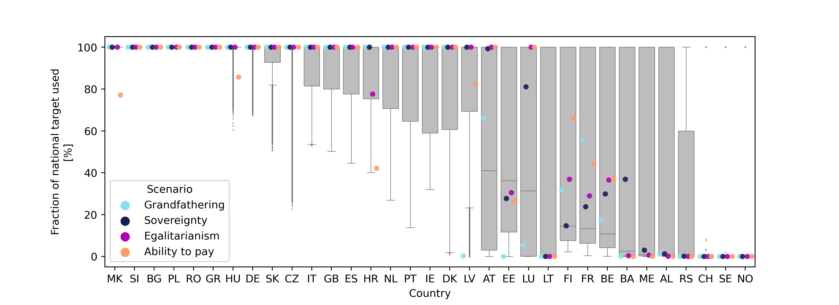 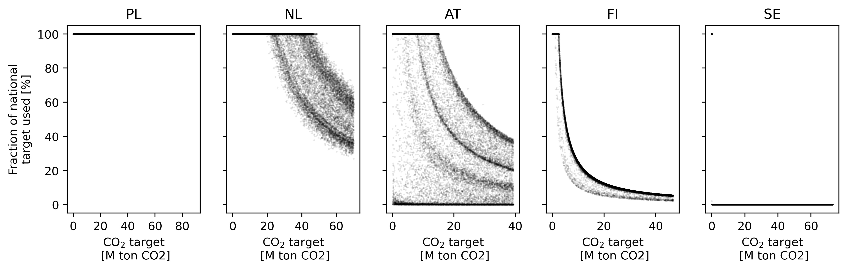

In this study, CO reduction targets were assigned to countries giving the countries the option to either use all allowable emission or simply leave them unused if it is economically optimal. The top panel of Figure [[fig:unused\_co2]](#fig:unused_co2) shows a box plot of the utilization of the national reduction targets for the individual countries across all configurations of national reduction target allocations. Here, a value of 100% means that the country is emitting as much CO as their reduction target allows, whereas 0% indicates that the country has no emissions although the CO reduction target is not 0. Below the box plot, the probability of full reduction target utilization has been shown for five illustrative countries [[fig:unused\_co2]](#fig:unused_co2). It features three distinct behavioral patterns for the countries. The countries either a) emit as much as the national target allows no matter what, b) sometimes overperform on the target or c) never have any emission. These different patterns are clearly highlighted in the lower panels: Poland is seen always emitting as much as the national target allows. The Netherlands, Austria, and Finland can be seen to be frequently over-performing, with less than the allowable emissions. The curved lines appearing in these figures correspond to the countries capping-out at a certain emission level. Finland can be seen having a clear upper bound to how much CO they will choose to emit, whereas Austria appears to have a wide range of possible outcomes available within the criteria used. This behavior is very likely a result of the strong correlation between Austria’s emissions with the emission from Germany and France found in Figure [[fig:co2\_correlation]](#fig:co2_correlation). In configurations where Germany is using less than their assigned emissions, Austria is providing dispatchable power and therefore itself has higher emissions. In scenarios where Germany and its neighbors have high allowable emissions, the demand for power imports from Austria drops, and it becomes cost-optimal for Austria not to use all the assigned emissions.

Studying how the five CO allocation approaches from Table [[tab:scenarios]](#tab:scenarios) are distributed on Figure [[fig:unused\_co2]](#fig:unused_co2) reveals that the Efficiency approach ensures that all national emission quotas are utilized 100%. In the Efficiency scheme no country is assigned more emissions than needed, whereas the other allocation approaches result in inefficient allocations increasing total system cost. Especially the Grandfathering scheme leads to a large share of assigned emissions being left unused. It should be noted, that as only the electricity sector is considered in this research, the 55% reduction target provides a somewhat conservative benchmark, considering that the electricity sector is expected to be the first to be decarbonized. As several countries already have decarbonized their electricity sector to a high extent, they can be expected to find it economically optimal to avoid using all the emissions they are assigned. Norway, Sweden and Switzerland can be seen to refrain from using their allocated emissions in most configurations of national reduction target allocations. This is in accordance with the findings shown in Figure [[fig:co2\_mwh\_box]](#fig:co2_mwh_box).

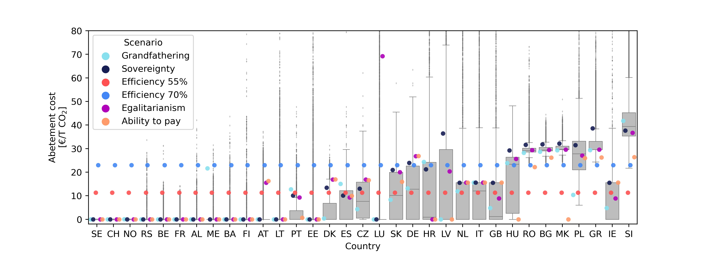 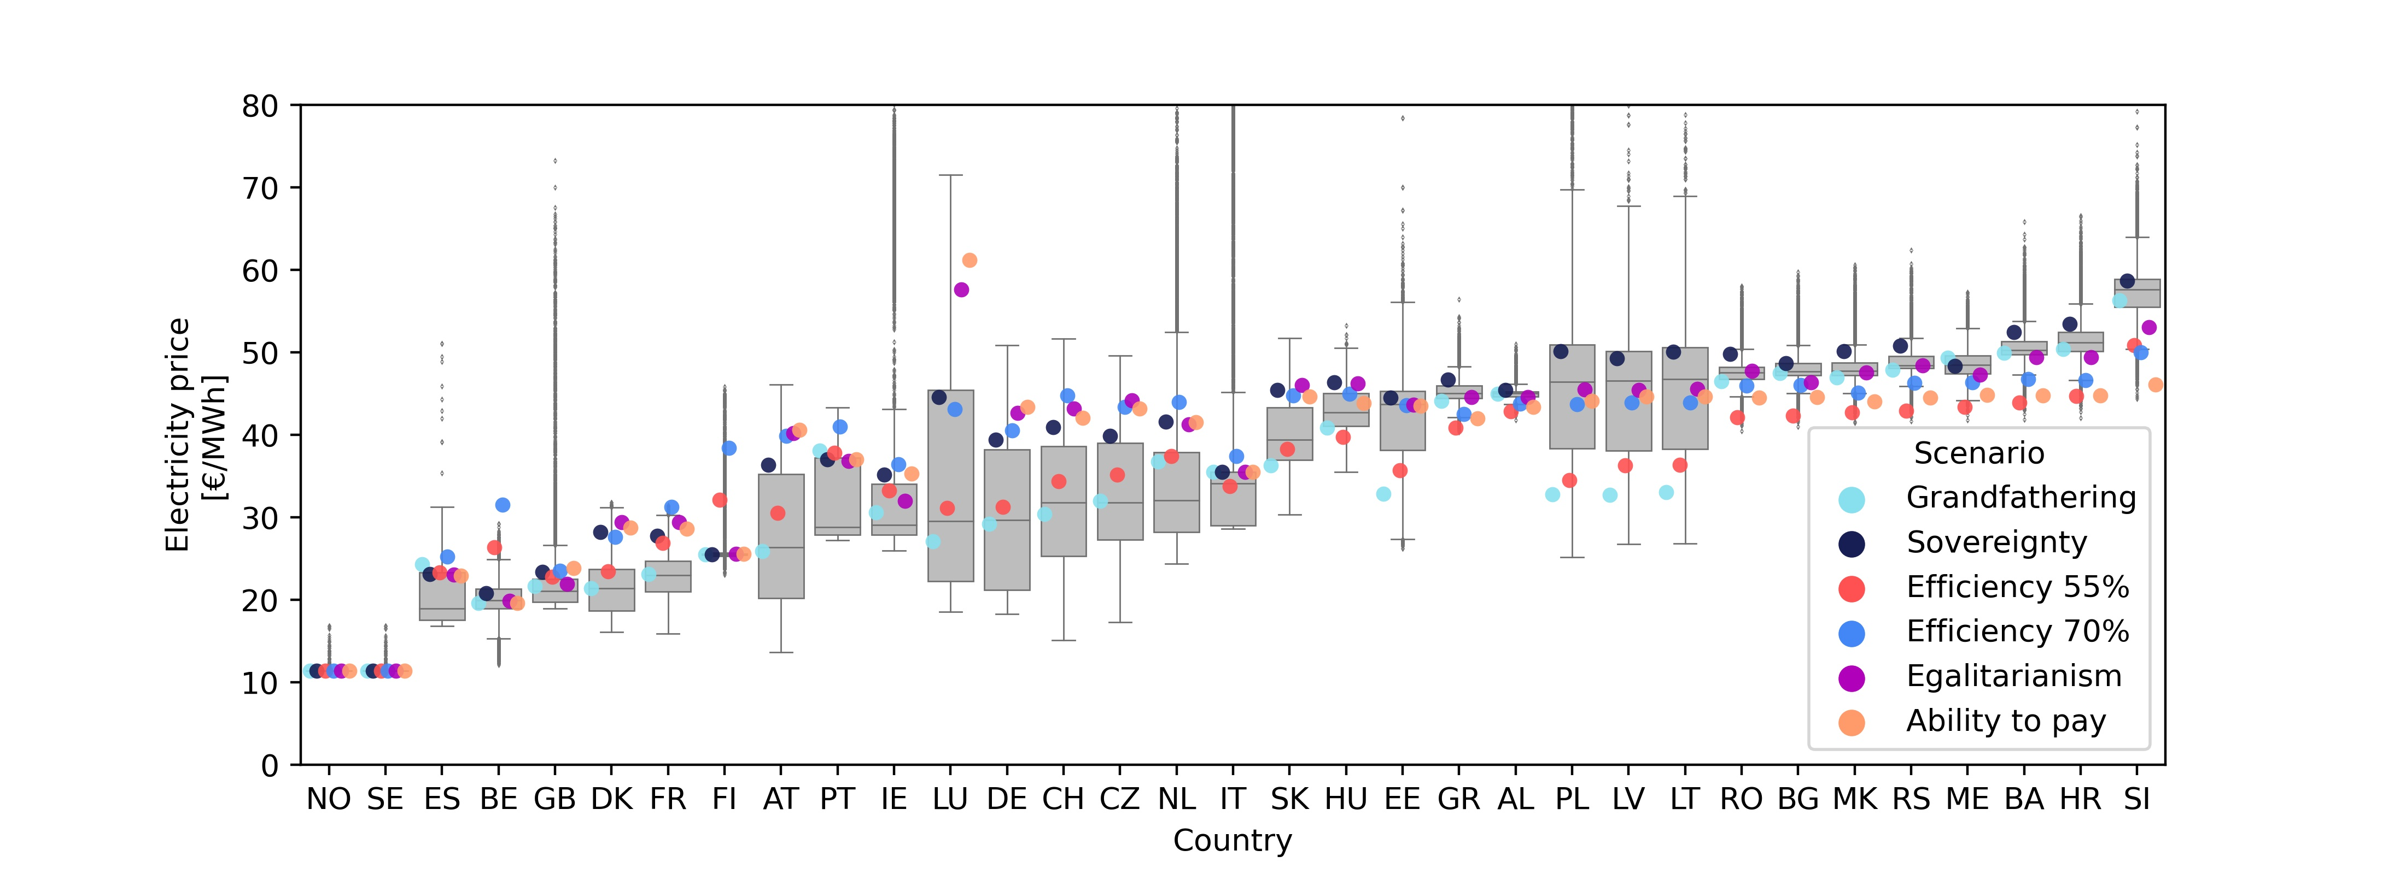

Imposing a limit on national CO emissions naturally triggers a shadow price on emissions abatement. In a linear optimization model such as the one used in this paper, the Lagrange/Kuhn-Tucker multiplier of the national CO constraints serves as a proxy for the national CO abatement cost. The Lagrange multiplier measures the change in objective function value caused by a change in the given constraint. Thus, the Lagrange multiplier associated with the national emission limits measures the increase in total system costs, when the given node is constrained on its emissions. CO abatement costs for all modeled configurations and approaches are shown in the top panel of Figure [[fig:prices]](#fig:prices). Equivalently, the hourly national electricity price can be found as the Lagrange multiplier value of the national energy balance constraints. Average electricity prices are shown on the lower panel of Figure [[fig:prices]](#fig:prices). For the formulation of the linear optimization problem, including the national CO constraint, and the nodal energy balance constraints, refer to the appendix.  
CO abatement costs are highly dependent on national CO reduction targets and the availability of renewable or low-carbon resources. An abatement cost will only occur if the national emission reduction constraint is binding. Thus, in a scenario where a given country is only utilizing parts of the allocated CO quota, an abatement cost of 0 will be obtained. In Figure [[fig:unused\_co2]](#fig:unused_co2) it is seen that a large number of the model countries are not utilizing the entire share of allocated emissions. Therefore, CO abatement costs of zero are seen for several countries in many of the outcomes in Figure [[fig:prices]](#fig:prices). Comparing the group of countries, which are observed to always utilize their allocated emissions (see Figure [[fig:unused\_co2]](#fig:unused_co2)), with the CO abatement costs on Figure [[fig:prices]](#fig:prices), these countries are seen to always have non-zero abatement cost. The abatement costs for these countries are ranging from €30 to €40 per ton CO in most configurations of national reduction target allocations, but with outliers ranging much higher.

On the top panel of Figure [[fig:prices]](#fig:prices)the Efficiency schemes are seen having a single global CO abatement cost determined by the joint emissions reduction target. The change in global CO abatement costs between the Efficiency configurations with 55% and 70% reduction are reflecting the increased socio-economic burden associated with higher emissions reductions.

Electricity prices are found to have a smaller spread for the individual countries as seen on the lower panel of Figure [[fig:prices]](#fig:prices). The robustness of the electricity price does, however, depend on the country observed with countries at each end of the figure having more robust prices, and countries towards the center having larger deviations. The countries observed to have constantly high prices are to a large extent the same countries that had high abatement costs. The countries observed to have high fluctuations in the electricity price are also the countries observed having strong correlations in national CO emissions on Figure [[fig:co2\_correlation]](#fig:co2_correlation). The observed electricity prices on the lower panel of Figure [[fig:prices]](#fig:prices) span from 10 €/MWh to above 70 €/MWh for some outlier outcomes. This span in power prices is rather large compared to current power prices which are around 50 €/MWh for most European countries.

## Discussion (Policy implications)

What has been considered here are possible reduction target configurations (or should we say obligations?) for the European power sector to reach a joint decarbonization target of 55% (baseyear 1990). This is not to be confused with strict quota allocation schemes, as the perspective here is broader and includes other more equitable allocation principles.

The power sector is currently subject to ETS; this article has considered possible other options highlighting four equity-based allocating configurations. Outcomes are in all cases challenging to predict due to the interlinked nature of electricity markets, however, an attempt was included to take account of transnational power interconnections and their capacities.

A fully efficient outcome is hard to obtain, as it requires close coordination and full information. Although in theory, EU ETS should ensure an efficient outcome, in practice information asymmetries are distorting the clearing of markets. Moreover, there are sunk costs causing dirty power producers to continue operating, due to the differences between marginal and average costs of production.

EU ETS is not equitable. The price of emission permits is the same across Europe, despite differences in GDP, income and purchasing power. Countries with low incomes tend to have inefficient and dirty power sectors, further reinforcing the inequities, as the costs to shoulder with decarbonization tend to be relatively larger to them. Commission proposes to create an ETS2 for transport and households, hence relevant to explore alternative allocation principles and their implications. Especially so as the Just Transition Fund is relatively loosely described.

The comprehensive modelling shows that although a wide range of outcomes is possible, most configurations will despite differences in allocation principles result in rather high electricity prices in all the ‘new’ member states in CEE, while the old benefit from lower prices, especially so Nordic, UK, and Spain.

The differences in abatement costs per unit of carbon can be misleading as to the distributional consequences, as the abatement effort will be less demanding in countries that are already partly decarbonized such as France. Still, not only can unit costs be expected to be relatively high in Balkan countries, but these countries are also facing a greater transformation overall, involving high absolute costs.

An overlap can be observed between the group of countries experiencing high abatement costs and the countries experiencing high electricity prices (Slovakia, Greece, Poland, Macedonia, Bulgaria, Romania). Countries included in both groups include several eastern European and Balkan countries. As these countries also have a tendency to have high income inequality, increasing electricity prices may significantly grow energy poverty.

The allocation principle of sovereignty results in the highest cost overshoot, showing the value of European cooperation. Still, the fluidity of the transactions in the power market and the facilitation of more interconnectors are making planning for decarbonization challenging. Some countries in the center of Europe are facing many different feasible outcomes, whereas countries in the periphery (Finland) will have less choices to make. The vision of a fully interconnected Europe is still only a distant dream.

The modelling shows that CO2 intensity will despite fulfillment of the 55% target remain high in Poland and other eastern countries, and continue to do so at a 70% reduction under the EU ETS. Thus providing a trail of high carbon costs well into the future under the EU ETS. Following the sovereignty configurations principle would result in a more equitable distribution of CO2 intensity, but it will drive higher CO2 abatement costs in Poland and other countries with high emission intensities.

Overall difference between the egalitarianism and ability-to-pay configuration principle is limited – the former may provide proxies that are easier to implement.











## Conclusion

EU ETS ensures efficient decarbonization of the European electricity sector but fails to provide a just energy transition. This paper investigates possible alternatives to EU ETS capable of delivering higher equity at minor cost increases. By performing a global sensitivity analysis on national emission reduction targets using an MCMC method, in combination with an energy system optimization model, reveals approximate distributions of all possible reduction target configurations.

The range of possible national CO reduction targets identified for the European electricity supply reveals that a cost increase of 5% from the cost-optimal solution is almost inevitable. Small deviations from the cost-optimal configuration of national CO reduction targets will lead to increases in total system cost. Accepting a moderate increase in system cost reveals a large range of possible alternatives to the configuration of national reduction targets obtained under EU ETS. Although some flexibility is available, countries, where emissions are hard to reduce, are found to have a high CO emission intensity in the majority of configurations. A strong correlation between emissions from three groups of countries located in central, North Eastern, and South-Eastern Europe were identified. These correlations reveal that enforcing a tight CO limit on one cluster country will move emissions to the other countries in the cluster. The likely explanation for this behavior is that carbon leakage between neighboring countries will occur when differences in national CO abatement cost increase. Analyzing the utilization of allocated emissions reveal a group of countries where it will be economically favorable to decarbonize the power sector, thus having zero emissions although emissions are allocated to the given country. A large group of countries does however favor some level of emissions from the power sector, but the level of favored emissions does in many cases depend on emissions from neighboring countries. National CO abatement cost associated with the sampled emission allocation schemes reveals large inequality with some countries being likely to have significantly higher abatement costs. A similar picture is found when studying power prices. The key takeaway from this study is the fact that the burden of transitioning our power supply is inequitably distributed, and actions must be taken to compensate.

# Appendix

## Sampling method

To draw possible CO target configurations the Adaptive Metropolis-Hastings (AMH) sampler is implemented . The AMH sampler is based around a Markov Chain process where samples are continuously drawn from a proposal distribution centered around the previous sample point. By controlling the width of the proposal distribution continuously the AMH sampler ensures efficient sampling. The AMH sampler is chosen as it is simple to implement while providing efficient sampling and fast mixing .

image

An arbitrary CO target configurations can be denoted as the vector , with each component of this vector representing the national CO emission target of the ’th country relative to the total CO emission target. The allowed emission for a given country can be determined as , where the is the total global amount of CO emissions allowed in tonnes of CO. Realizations of the variables are denoted with subscript . It is important to note that the sum of can be greater than 1, and thus the combined emission targets can add up to more than the total global amount of CO emissions allowed . As the rejection criteria is based on the realized emissions, a sample where the sum of is greater than 1 can be accepted if not all allowed emissions are realized. Similarly can also sum to less than 1. In such a case the global emission reductions will be less than the required 55%.

Given a starting point the AMH sampler will continuously generate new sample proposals . New samples are drawn from the proposal distribution centered around the previous sample. The proposal distribution is defined as a uniform distribution around the previous sample point with the width . Thus the maximal change in each variable per iteration is . There are however a few caveats. As the variables considered are fractions of a total CO budget, they are constrained to be between 0 and 1. Therefore, the uniform distribution is bounded not to exceed this area. The starting point used is the cost-optimal scenario also denoted as the Efficiency scenario. A burn-in period of 100 samples is used by discarding the first 100 samples of each chain to remove any bias towards the starting point.

The distribution width is tuned continuously as more information about the solutions space is obtained. By setting too low, the sampler will need an excessive amount of samples to explore the entire solution space. On the other hand, setting too high will result in the rejection of too many samples. By continuously monitoring the acceptance rate, it is possible to determine if the chain is taking either too short or long steps. If the acceptance rate is very high should be increased, and if the acceptance rate is low should be decreased. In practice, this is implemented by letting the sampler run for a number of iterations and evaluating the acceptance rate in that batch of samples. In this implementation of the AMH sampler, is updated by continuously monitoring the acceptance ratio of the samples. When the acceptance ratio is below a user-specified value, is incremented by a small amount , and vice versa when the acceptance ratio is too high. An value of 0.05 and a desired acceptance ratio of 80% have been used throughout this work.

The feasibility of a proposed sample is evaluated using the energy system optimization model. If the solution to the energy system optimization model given as input satisfies all criteria from Table [[tab:feasa]](#tab:feasa) the sample is accepted. Otherwise, the sample is rejected and a new proposal sample is drawn. When a proposed sample is accepted it is assigned index , such that . If a sample is rejected the previous sample point is stored instead . The process of drawing samples from the proposal distribution and either accepting or rejecting them is repeated until sufficient sample size is reached. The process is illustrated in Figure [[fig:method]](#fig:method).

The result is a set of realizations of that can ensure feasible operation of the model, global emission reductions higher than the base scenario, and a total system cost that is no more than 18% higher than that of the base scenario. If enough samples are drawn the distribution of the set of realizations will approximate all solutions satisfying the above-mentioned criteria.

In practice, the above algorithm is implemented as a parallel process with multiple chains running simultaneously. The samples from the parallel chains can then be merged at the end of the sampling process.

## Energy system optimization model

The joint capacity and dispatch optimization model used in this work is based on the PyPSA-Eur-Sec model . The PyPSA-Eur-Sec model to a high extend depends on data imports from the PyPSA-Eur model . The model formulated in this work represents a 2030 brownfield scenario of the European electricity supply spanning 33 ENTSO-E member countries. All existing plus the planned transmission capacities in the Ten Year Network Development Plan (TYNDP) is included. Transmission capacities are seen in Figure [[fig:starting\_point]](#fig:starting_point).

A brownfield scenario is generated where existing capacities that are planned to be in operation by 2030 are included in the model. The included brownfield capacities are seen in Table [3](#tab:brownfield_cap). Existing conventional capacities are found from the power plant matching database , while renewable capacities are found from the IRENA annual statistics . A minimum requirement of 55% CO reductions have been used throughout this work, corresponding to a yearly CO budget of 666.85 M ton CO.

Some technology capacities can be expanded to meet energy demand at a certain cost. Cost of the expandable technologies are given in Table [1](#tab:tech_cost). Efficiency and emission data are available in Table [2](#tab:tech_data). Technology costs are primarily based on the 2030 cost prediction given by the Danish Energy Agency in their technology data catalog . A discount rate of 7% has been used to calculate annualized costs using the annuity factor given in Equation [[eq:annuity]](#eq:annuity). Here is the discount rate and is the technology lifetime.

The model of the European power sector is formulated as a linear optimization problem, consisting of an objective function along with a set of constraints. Throughout this description of the model, the model variables are split in two vectors namely and . Where describes the national CO reduction target given by the MCMC sampler . Here is the national CO target in tons CO for all model countries . The remaining variables represent technology capacities and dispatch . Here index is indexing the technology for all technologies included in the model, index is indexing the hour for all hours in the year, and represent the transmission line. The variables determined in the optimization process are thus:

* : Hourly dispatch of energy from the given plants in the given countries with the marginal cost .
* : Total installed capacity of the given technologies in the given countries with the capital cost .
* : Total installed transmission capacity for all lines with the fixed annualized capacity cost .

The model is then formulated as a linear problem following the standard formulation given as:

The national CO targets are given by the MCMC sampler and are thus not optimized in the model. Only the technical variables are optimized in the optimization problem.

The objective function of the model is to minimize total system cost and can be formulated as follows:

The model assumes perfect competition and foresight as well as long-term market equilibrium. For all model nodes and all hours in the year, a power balance constraint is enforced requiring that the energy demand is fulfilled. Energy demand data is taken from the ENTSO-E data portal and decomposed in industrial and residential demand following the method given in . The incidence matrix describing the line connections is given by and the hourly power flowing through each line is described as . The nodal power balance constraint can then be formulated as:

The dispatch of each technology is limited by the installed technology capacity . The dispatch of renewable energy generators such as wind and solar are furthermore limited by the hourly capacity factor . The capacity factor for conventional power plants is 1, whereas it is generated from weather data for the renewable generators. A detailed explanation of the derivation of renewable generation potentials is given in .

Similarly, the power flowing through the transmission lines is also limited by the installed capacity. As the direction of the transmission is without significance it is the absolute transmission that is limited.

The maximum capacity allowed for each technology is determined by geographical potentials available .

CO emissions can be constrained in two ways. Either through a global constraint on emissions, or by national constraints on emissions. The global CO reduction constraint is formulated as:

Here the is the global emissions limit given in ton CO. Note that only a single constraint is given here. Limiting emissions through national constraints can be done by defining a constraint for each country in the model. The national emissions targets are given by the MCMC sampler.

The global CO constraint (Equation [[eq:global\_co2]](#eq:global_co2)) is only used in the Efficiency scenario. In all other scenarios, the national CO targets are explicitly given, either by the sampler or following a certain allocation scheme.

When the model is solved the Lagrange multipliers associated with every constraint are also obtained as an output. The value of these Lagrange multipliers represents the cost increase/decrease associated with tightening/loosening the constraint by one unit. Thus by evaluating the Lagrange multipliers associated with the energy balance constraint (Equation [[eq:equality\_constraint]](#eq:equality_constraint)) the nodal hourly electricity price can be obtained. Similarly, the Lagrange multiplier of the national CO target constraint (Equation [[eq:national\_co2]](#eq:national_co2)) provides a proxy for the national CO abatement cost.

Technology costs of new technologies.

|  |  |  |  |  |
| --- | --- | --- | --- | --- |
| Technology | Capital cost | FOM | VOM | Lifetime |
|  | Eur/kW | %/year | Eur/MWh | years |
| OCGT | 435.2 | 1.78 | 4.5 | 25 |
| Offshore wind turbine | 1573.2 | 2.29 | 2.67 | 30 |
| Offshore wind AC connection submarine | 2685.0\* | 0 | 0 | 30 |
| Offshore wind AC connection underground | 1342.0\* | 0 | 0 | 30 |
| Offshore wind AC station | 250.0 | 0 | 0 | 30 |
| Offshore wind DC connection submarine | 2000.0\* | 0 | 0 | 30 |
| Offshore wind DC connection underground | 1000.0\* | 0 | 0 | 30 |
| Offshore wind DC station | 400 | 0 | 0 | 30 |
| Onshore wind | 1035.6 | 1.22 | 1.35 | 30 |
| Utility scale solar PV | 376.3 | 1.93 | 0 | 40 |
| Electrolysis | 550.0 | 5.0 | 0 | 25 |
| Fuel Cell | 1100.0 | 5.0 | 0 | 10 |
| Hydrogen storage tank | 44.0\*\* | 1.11 | 0 | 30 |
| Hydrogen underground storage | 2.0\*\* | 0 | 0 | 100 |
| Battery inverter | 160.0 | 0.34 | 0 | 25 |
| Battery storage | 142.0\*\* | 0 | 0 | 25 |
| \* Eur/MW/km |  |  |  |  |
| \*\* Eur/kWh |  |  |  |  |

Technology data

|  |  |  |
| --- | --- | --- |
| Technology | Efficiency | Emissions |
|  | % | ton CO/MWh |
| OCGT | 41 | 0.49 |
| CCGT | 58 | 0.34 |
| Coal | 33 | 1.00 |
| Lignite | 33 | 1.24 |
| Oil | 35 | 0.77 |
| Electrolysis | 66 | 0 |
| Fuel Cell | 50 | 0 |
| Battery inverter | 96 | 0 |

Existing generator technology capacities by 2030 in MW

|  | Offshore wind | Onshore wind | Run off river | Solar PV | CCGT | OCGT | Coal | Lignite | Nuclear | Oil |
| --- | --- | --- | --- | --- | --- | --- | --- | --- | --- | --- |
| AT | 0.0 | 3132.7 | 4478.5 | 1438.6 | 2481.7 | 1313.5 | 991.5 | 0.0 | 0.0 | 0.0 |
| BA | 0.0 | 50.6 | 0.0 | 0.0 | 0.0 | 0.0 | 0.0 | 0.0 | 0.0 | 0.0 |
| BE | 1185.9 | 2074.8 | 59.0 | 3984.5 | 3801.9 | 1460.6 | 1524.8 | 0.0 | 5925.8 | 0.0 |
| BG | 0.0 | 691.0 | 22.4 | 1029.0 | 0.0 | 782.0 | 4963.7 | 3993.0 | 2000.0 | 0.0 |
| CH | 0.0 | 63.0 | 5280.0 | 2171.0 | 0.0 | 0.0 | 0.0 | 0.0 | 3430.0 | 0.0 |
| CZ | 0.0 | 316.2 | 40.2 | 2074.3 | 336.8 | 0.0 | 7184.7 | 725.7 | 2660.0 | 0.0 |
| DE | 6396.0 | 52447.0 | 2997.0 | 45179.0 | 18120.9 | 8044.3 | 28069.4 | 20833.5 | 15788.4 | 3696.4 |
| DK | 1708.1 | 4431.2 | 0.0 | 991.0 | 100.0 | 1427.4 | 3629.9 | 0.0 | 0.0 | 665.0 |
| EE | 0.0 | 329.8 | 0.0 | 25.4 | 173.0 | 250.0 | 0.0 | 0.0 | 0.0 | 2111.0 |
| ES | 0.0 | 23433.1 | 16.4 | 4753.5 | 24344.3 | 2942.6 | 6519.7 | 3081.2 | 7572.6 | 3533.4 |
| FI | 67.0 | 1971.3 | 1289.6 | 123.0 | 648.0 | 677.7 | 3039.7 | 0.0 | 2784.0 | 1225.4 |
| FR | 0.0 | 14898.1 | 5780.8 | 9604.0 | 5611.0 | 1066.0 | 4293.3 | 0.0 | 63130.0 | 7172.1 |
| GB | 8212.7 | 13553.9 | 685.2 | 13107.3 | 32824.3 | 921.5 | 14475.0 | 0.0 | 11261.0 | 2801.9 |
| GR | 0.0 | 2877.5 | 103.1 | 2650.6 | 4482.0 | 417.0 | 1550.0 | 3905.0 | 0.0 | 0.0 |
| HR | 0.0 | 580.3 | 278.7 | 67.4 | 369.6 | 82.5 | 304.3 | 0.0 | 0.0 | 647.8 |
| HU | 0.0 | 335.0 | 19.7 | 724.0 | 1259.2 | 2368.7 | 42.3 | 1180.2 | 1886.8 | 410.0 |
| IE | 25.2 | 3650.9 | 216.0 | 21.8 | 2946.0 | 1320.0 | 855.0 | 0.0 | 0.0 | 907.0 |
| IT | 0.0 | 10230.2 | 6563.7 | 20073.6 | 34438.1 | 6491.8 | 10926.5 | 0.0 | 0.0 | 6145.0 |
| LT | 0.0 | 532.0 | 0.0 | 81.9 | 0.0 | 1575.0 | 0.0 | 0.0 | 0.0 | 0.0 |
| LU | 0.0 | 114.2 | 30.9 | 124.7 | 350.5 | 0.0 | 0.0 | 0.0 | 0.0 | 0.0 |
| LV | 0.0 | 62.9 | 642.1 | 0.0 | 1025.0 | 0.0 | 0.0 | 0.0 | 0.0 | 0.0 |
| ME | 0.0 | 118.0 | 0.0 | 0.0 | 0.0 | 0.0 | 0.0 | 0.0 | 0.0 | 0.0 |
| MK | 0.0 | 37.0 | 41.6 | 17.0 | 0.0 | 0.0 | 0.0 | 824.0 | 0.0 | 0.0 |
| NL | 957.0 | 3491.0 | 0.0 | 4522.0 | 13582.0 | 3991.0 | 5591.0 | 0.0 | 492.0 | 0.0 |
| NO | 0.0 | 1708.0 | 0.0 | 53.4 | 450.0 | 773.1 | 0.0 | 0.0 | 0.0 | 0.0 |
| PL | 0.0 | 5762.1 | 14.4 | 562.0 | 326.0 | 1032.9 | 21588.5 | 9406.0 | 0.0 | 345.0 |
| PT | 0.0 | 5172.4 | 1615.5 | 665.4 | 3829.0 | 0.0 | 1756.0 | 0.0 | 0.0 | 0.0 |
| RO | 0.0 | 3243.0 | 870.4 | 1385.7 | 1080.0 | 2282.0 | 1506.0 | 4779.2 | 1298.0 | 87.5 |
| RS | 0.0 | 25.0 | 0.0 | 0.0 | 0.0 | 0.0 | 0.0 | 0.0 | 0.0 | 0.0 |
| SE | 204.0 | 7097.0 | 1955.9 | 481.0 | 708.0 | 0.0 | 130.0 | 0.0 | 9532.0 | 2135.0 |
| SI | 0.0 | 0.0 | 861.3 | 251.8 | 832.0 | 449.0 | 246.0 | 944.0 | 727.0 | 143.6 |
| SK | 0.0 | 0.0 | 641.3 | 533.0 | 648.0 | 0.0 | 440.0 | 486.0 | 1940.0 | 0.0 |

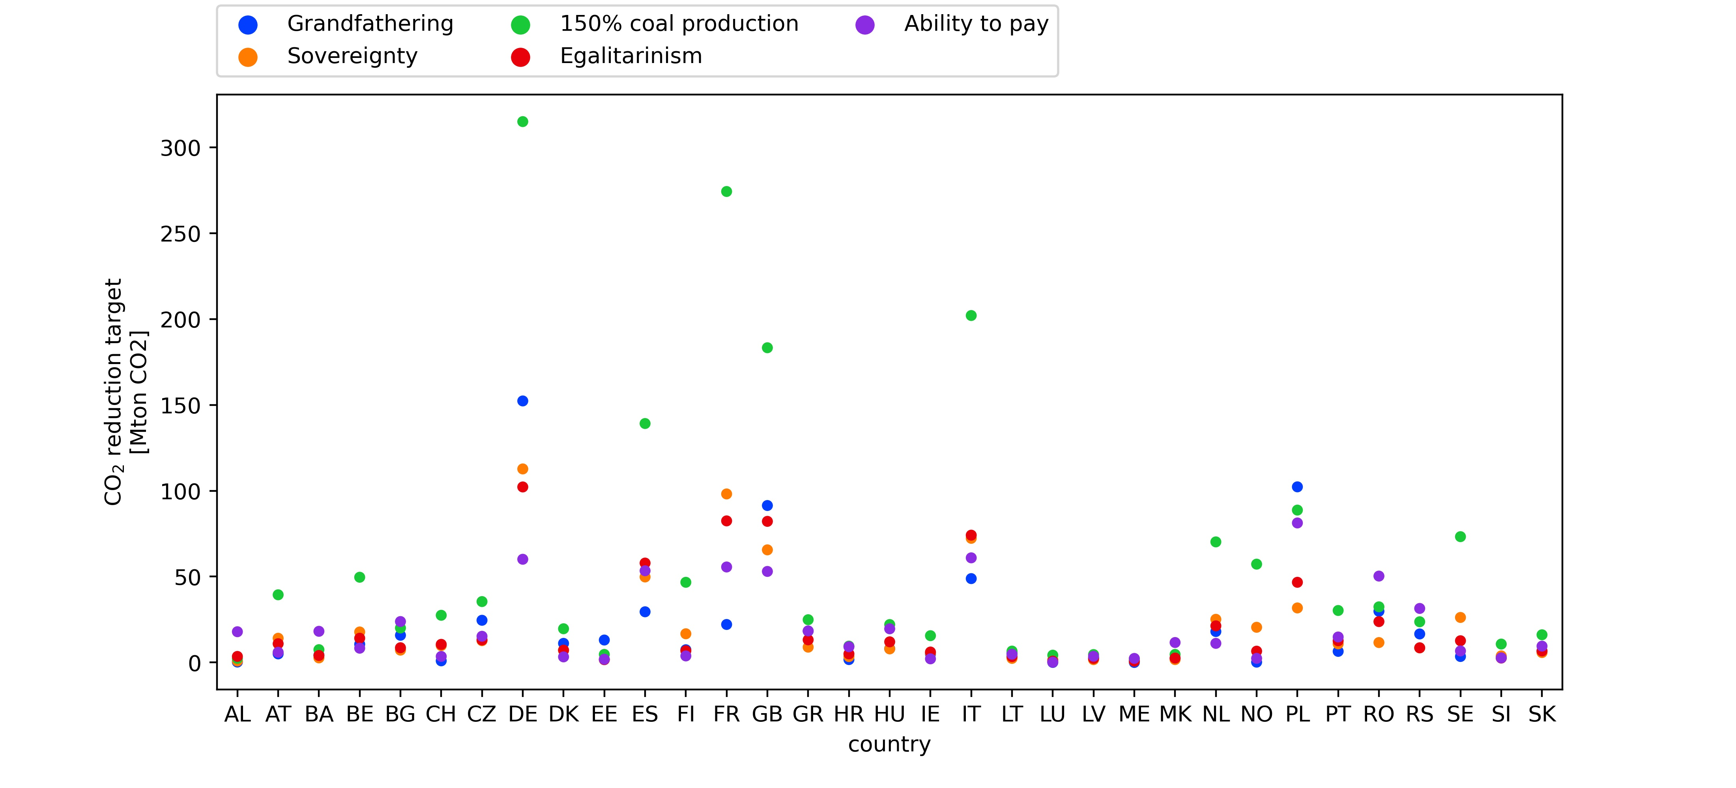

## Scenarios with equal realised emissions

In this work a decision was made to compare scenarios (see Table [[tab:scenarios]](#tab:scenarios)) that assign CO targets summing up to the same total CO budget. The CO targets are not always fully utilised as some countries find it economically favourable to reduce emissions despite being assigned allowable emissions. The result is that the scenarios compared have different global emission reductions although having the same CO budget as seen in Figure [1](#fig:co2red_cost). The shares of unused CO is seen in Figure [[fig:unused\_co2]](#fig:unused_co2). Alternatively one could design the scenarios to have equal realised global emissions. By adjusting the CO budget for the individual scenarios, realised emissions corresponding to a 55% emission reduction can be achieved. Figure [3](#fig:all55_scenarios) b) shows the relationship between assigned emissions and realised emissions for all configuration strategies listed in Table [[tab:scenarios]](#tab:scenarios). The figure clearly shows configuration strategies other than Efficiency having lower realised than assigned emissions. Figure [3](#fig:all55_scenarios) a) shows the cost increase associated with the unused CO emissions. A cost increase for the configuration strategies is seen even when the realised emissions correspond to a 55% CO reduction for all strategies.

a) Shows the relationship between cost increase and CO_2 reduction for all configuration strategies. b) Realised CO_2 emissions from all configuration strategies plotted against the sum of assigned CO_2 targets. The horizontal black line represents the CO_2 budget associated with a 55% CO_2 reduction. 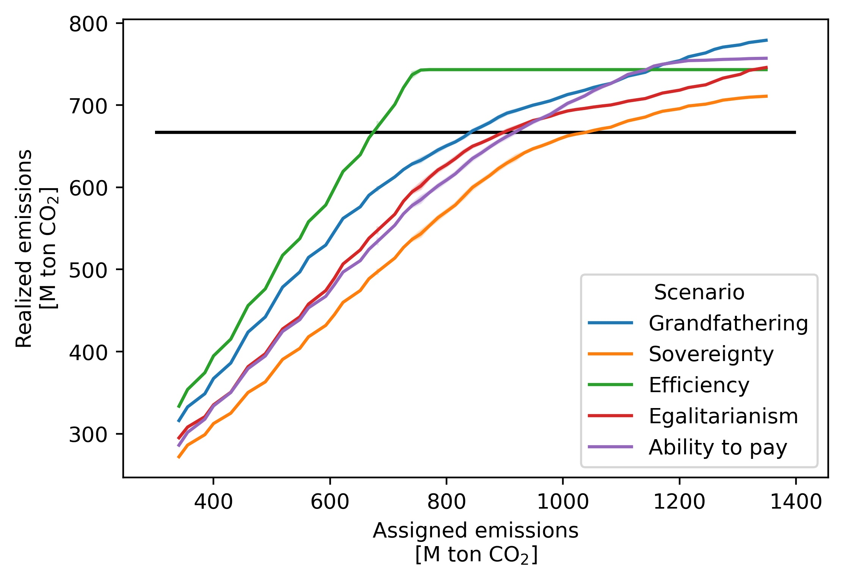

In this section the result found by selecting scenarios with realised emissions corresponding to a 55% CO reduction is shown. Figure [[fig:all55\_boxplots]](#fig:all55_boxplots) shows figures corresponding to Figure [[fig:co2\_mwh\_box]](#fig:co2_mwh_box) and [[fig:prices]](#fig:prices), but the configuration strategies shown all have realized emissions corresponding to a 55% CO reduction. Thus the configurations shown here all have higher realised emissions then the configurations used in Figure [[fig:co2\_mwh\_box]](#fig:co2_mwh_box) and [[fig:prices]](#fig:prices). The configurations studied in this section with realized emissions corresponding to a 55% CO reduction will be referred to as the "55% realised" configurations, whereas the original scenarios with equal CO budgets will be referred to as the "55% CO budget" configurations.

Comparing the "55% CO budget" configurations found on Figures [[fig:co2\_mwh\_box]](#fig:co2_mwh_box) and [[fig:prices]](#fig:prices) with the "55% realised" configurations, found on Figure [[fig:all55\_boxplots]](#fig:all55_boxplots), the "55% realised" configurations are found to be more equal. Across all measures shown in Figure [[fig:all55\_boxplots]](#fig:all55_boxplots), the "55% realised" configurations deviate less from each other than the "55% CO budget" configurations does on Figures [[fig:co2\_mwh\_box]](#fig:co2_mwh_box) and [[fig:prices]](#fig:prices). This behaviour is expected as the "55% realised" configurations redistribute unused CO from countries finding it favourable to reduce emissions, to countries where higher emissions are desired. Thus, the "55% realised" configurations become more similar to the Efficiency configuration compared to the "55% CO budget" configurations. This is also reflected in the significant cost decrease between the "55% realised" and "55% CO budget" configuration shown on Figure [3](#fig:all55_scenarios) a). Furthermore, Figure [[fig:all55\_unused\_co2]](#fig:all55_unused_co2) shows how the "55% realised" scenarios have much less unused CO emissions than the "55% CO budget" configuration.

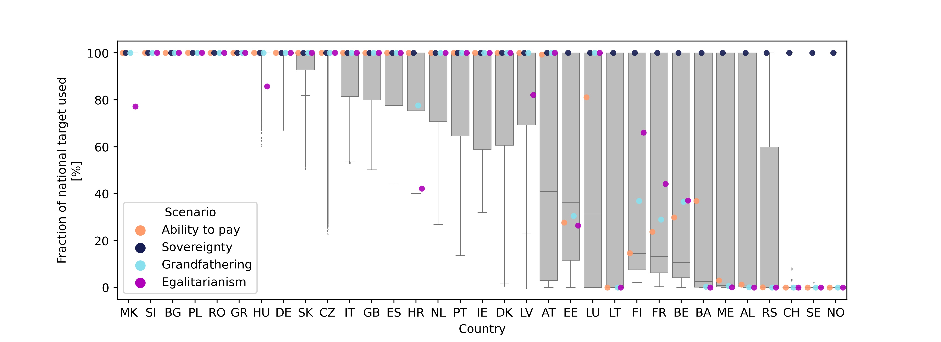

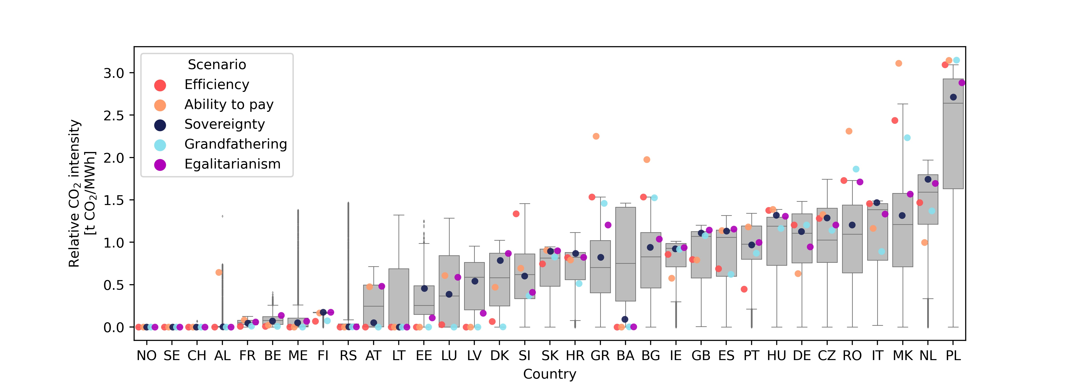 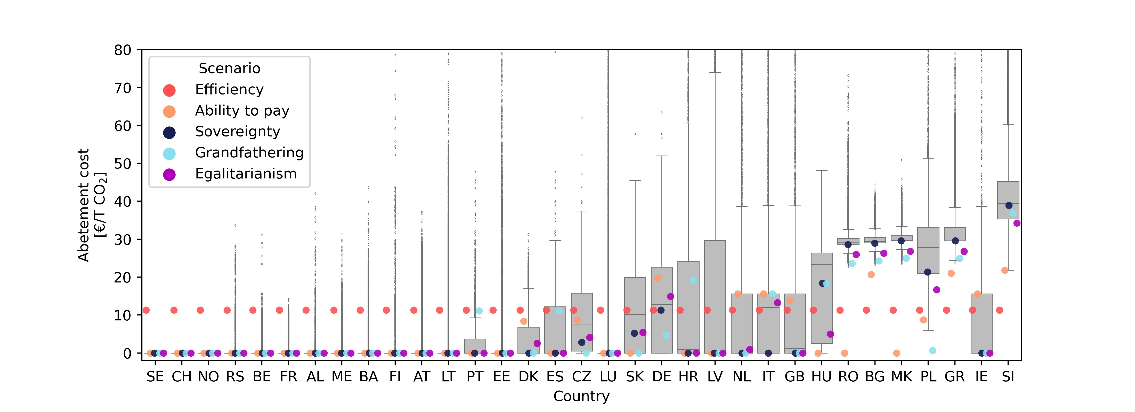

1. Lead author, Email: ttp@eng.au.dk [↑](#footnote-ref-2)